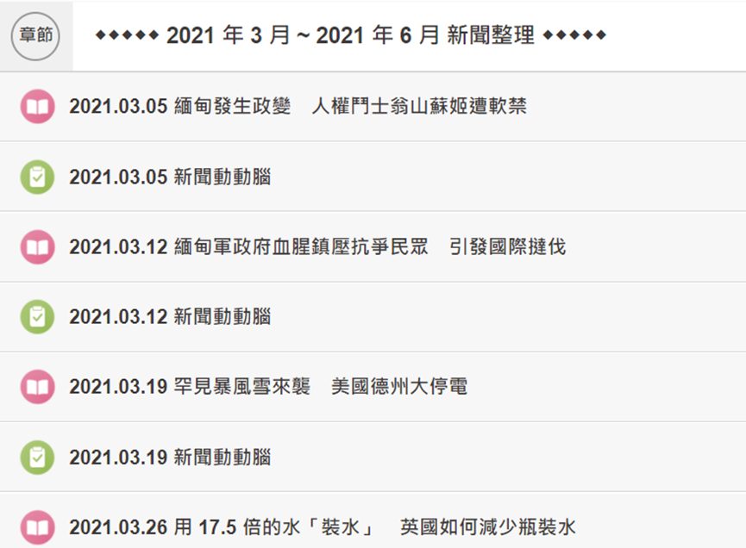

１．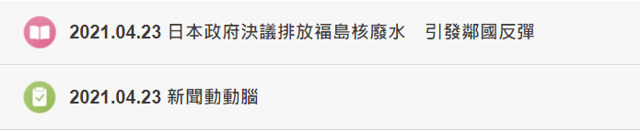

２．



３．

４．

５．

６．